##insert title picture

##adjust logos below to specific case; add counterpart logos if applicable

|  |
| --- |
| Title of Mitigation Action  Subtitle of Mitigation Action |

**##Transport Mitigation Action Outline Template (Version June 2019)**

**##Idea of this template:**

This Template contains an annotated outline to facilitate the design of Transport Mitigation Actions / NAMAs. This template contains a guideline and many real world examples facilitating the development and description of such actions. The template was used in several countries since 2011 and has undergone a continuous improvement process integrating the various lessons learned.

**##How to use this template:**

* The black text provides the standard document structure.
* The grey text gives guidance and contains many examples.
* Final documents are expected to be approx. 50 – 100 pages.
* Delete the text on this page at the end.

**##Further help and tools**

* T-NAMA Handbook “Navigating Transport NAMAs”: <https://www.changing-transport.org/wp-content/uploads/2015_Eckermannetal_NavigatingTransportNAMAsHandbook.pdf>
* T-NAMA Toolbox: <http://www.transferproject.org/resources/toolbox/>
* Examples of NAMA Concept Documents: <https://www.changing-transport.org/publications/?_sft_category=mitigation-action-outline>
* MRV Reference Document: <https://www.changing-transport.org/wp-content/uploads/2018_Reference_Document_Transparency-in-Transport_2nd-ed.pdf>
* UNFCCC Compendium: <https://www.changing-transport.org/wp-content/uploads/2018_Compendium_Passenger_and_Freight_Transport_Volume.pdf>

|  |  |  |
| --- | --- | --- |
|  | | |
| **Project Background**  Transport is the highest energy-consuming sector in 40% of all countries worldwide, and causes about a quarter of energy-related CO2 emissions. To limit global warming to two degrees, an extensive transformation and decarbonisation of transport is necessary. The TRANSfer project’s objective is to increase the efforts of developing countries and emerging economies for climate-friendly transport. The project acts as a mitigation action preparation facility and thus, specifically supports the implementation of the Nationally Determined Contributions (NDC) of the Paris Agreement. The project supports several countries (including Peru, Colombia, the Philippines, Thailand, Indonesia) in developing greenhouse gas mitigation measures in transport.  The TRANSfer project is implemented by GIZ and funded by the International Climate Initiative (IKI) of the German Ministry for the Environment, Nature Conservation and Nuclear Safety (BMU) and operates on three levels. | | |
| Mobilise  Facilitating the MobiliseYourCity Partnership  The goal of the multi-stakeholder partnership MobiliseYourCity, which is currently being supported by France, Germany and the European Commission, is that 100 cities and 20 national governments commit to ambitious climate action targets for urban transport and take appropriate measures. | **Prepare**  **Preparation of Mitigation Measures**  Standardised support packages (toolkits) are developed and used for the preparation of selected mitigation measures. As a result, measures can be prepared more efficiently, until they are ready for implementation and eligible for (climate) financing. Accumulated over 10 years, the targeted measures aim for a total reduction potential of 60 MtCO2. | **Stimulate**  **Knowledge products, Training, and Dialogue**  Based on these experiences, TRANSfer is sharing and disseminating best practises. This is achieved through the development of knowledge products, the organisation of events and trainings, and the contribution to an increasing level of ambition. Personal exchange of experience and dialogue is promoted at events, including the annual Transport and Climate Change Week in Berlin, the United Nations Climate Change Conference (COP) or the International Transport Forum. |
| Meet us at[**www.changing-transport.org**](http://www.changing-transport.org) | | |

Disclaimer

The content presented in this document has been compiled with the utmost care. Nevertheless, GIZ gives no guarantee that the information provided is current, accurate, complete or error-free. GIZ accepts no liability for damage or loss arising directly or indirectly from the use of this document, provided it has not been caused intentionally or by gross negligence.

GIZ expressly reserves the right to modify or append this document in part or in whole without prior notice, or to halt publication completely or for a limited period. Cartographic presentations in no way constitute recognition under international law of boundaries and territories. The content of GIZ GmbH’s documents is protected by copyright. The images used are marked with photo credits where required by law. The use of any images requires the prior consent of GIZ GmbH, if not stated otherwise.

Acknowledgements

We would especially like to express our sincere gratitude to ##…

Content

Executive Summary 3

1. Introduction 9

2. Sector overview: [insert Mitigation Action name and country, e.g. Public Transport in Colombia] 11

2.1 Relevance of the (sub-)sector 11

2.2 Transport and climate policy context 11

2.3 Governance, market organization and relevant stakeholders 12

2.4 Finance and current business model(s) 15

2.5 Related initiatives 15

3. Barriers to decarbonizing / to a low carbon [insert Mitigation Action name and country] 17

4. The Mitigation Action 19

4.1 Objective and concept 19

4.2 Scope 22

4.3 GHG mitigation actions (direct mitigation measures) 22

4.4 Supportive actions (framework conditions, capacity development) 23

4.5 Implementation arrangement (organizational measures) 23

4.6 Transformational change 24

4.7 Action plan 24

4.8 Risk assessment 26

5. Financing concept 27

5.1 Overview of costs and revenues 27

5.2 Financial viability 31

5.3 Economic viability 31

5.4 Financing mechanism and structure 32

5.5 Scale of investment and support needs for different ambition levels 34

6. Expected benefits and MRV approach 36

6.1 Cause-impact chain 36

6.2 Assessment boundaries 38

6.3 Ex ante impact assessment 39

6.3.1 Baseline and mitigation scenarios 39

6.3.2 Methodology for calculation 40

6.3.3 Data 41

6.3.4 Expected benefits 42

6.4 Monitoring and reporting plan 45

Bibliography 49

Annex 1: Logframe 50

Annex 2: Cause-effect chain 51

Annex 3: Core elements from financial studies 52

List of Tables

Table 1: The Mitigation Action at a glance ##for additional table just copy-paste and then right click on the number (i.e. the field function) and update the field (the correct number appears autmatically) 3

Table 2: The Mitigation Action at a glance 21

Table 3: Name of Table 25

Table 4: Average unit costs and revenues of TAnDEm’s direct mitigation measures 28

Table 5: Annual maintenance cost of baseline jeepneys by route 30

Table 6: Assessment boundares 38

Table 7: BAU and mitigation scenarios 40

Table 8: Used data 41

Table 9: Ex ante GHG Impact Assessment 2016 – 2026 42

Table 10: Total pollutant emissions avoided in Metro Manila from 2016 to 2026 (tons/year) 44

Table 11: Qualitative assessment of co-benefits (sustainable development benefits) 44

Table 12: Parameters for GHG impact monitoring 46

Table 13: Monitoring parameters for sustainable development impacts 47

List of Figures

Figure 1: Financing mechanism of direct mitigation measures ##for additional figure just copy-paste and then right click on the number (i.e. the field function) and update the field (the correct number appears autmatically) 34

Figure 2: Scale of investment and financial support needed 34

Exchange rates

##mandatory for any publication; adjust list to your context: insert your currency in the left column followed always by EU and US exchange rates

|  |  |  |  |
| --- | --- | --- | --- |
| Local Currency | EUR | USD | Date |
| 1 ZAR | 0.07012 EUR | 0.09649 USD | 13.5.2014 |

Executive Summary

***Maximum 5 pages, not more!***

**Typically, you draft the summary after completing the rest of the document.**

Develop a **high quality executive summary** that generates appetite for reading and helps the reader understand all main aspects rights from the beginning.

Use the subtitles, tables & figures below to structure the summary and make it easy to read.

**Mandatory numbers** to be included with year & source somewhere in the summary:

* Total GHG emissions in the country
* Total energy related emissions in the county and % of total
* Total transport emissions in the country and % of total and energy related
* Expected mitigation potential   
  (1) accumulated over ten years indicating timespan and   
  (2) average yearly mitigation in this period.
* % of total or energy related emissions emissions mitigated by the mitigation action
* % of transport sector emissions mitigated by the mitigation action
* Description of overall NDC target and if available sectoral target and contribution of the mitigation action to achieve this target. MAKE SURE TO MAKE timeframe of mitigation action and NDC / important sector policies compatible.
* important trends / drivers (e.g. motorization growth rate, number of vehicles)

Place the following overview table somewhere in the Executive Summary.

Table 1: The Mitigation Action at a glance ##for additional table just copy-paste and then right click on the number (i.e. the field function) and update the field (the correct number appears autmatically)

|  |  |  |  |
| --- | --- | --- | --- |
| Contribution to NDC implementation | ##specify | | |
| Type of action | Policy / Programme / Regulation / Economic instrument / Etc. | Subsector | e.g. road based public transport, all modes |
| Geographical scope | e.g. full country, certain regions; medium sized cities; specific cities X, Y, Z | Type of policy instruments | Regulations: yes / no  Economic instruments: yes / no  Public spending/ investments: yes / no  Communication and information: yes / no |
| Organisation | Responsible organization: xxx  Involved national partners: xxx  Involved international organizations: xxx | | |
| Main mitigation measures | (1) xxx ##take information from chapter 4.3  (2) xxx  (3) xxx | | |
| Schedule | **Phase 1:** “Preparation” (2013-2014)  **Phase 2:** “Improvement of framework conditions, pilot-testing of programs and generation of good practice / showcases” (2015 – 2017)  **Phase 3:** Full scale implementation (2017 onwards, partly in parallel to phase 2) | | |
| GHG mitigation effect and other benefits | GHG mitigation: X MtCO2e between 20xx and 20xx (always over 10 years!!!); average annual mitigation X MtCO2e  Other benefitss: xxx | | |
| Feasibility | Financial feasibility: ##provide information re micro-economic feasibility and eventually details on required incentives  Economic feasibility: ##provide quant. estimation of economic benefits, CBA ratio, etc. | | |
| Type of required support | Technical support: xxx  Financial support: xxx | | |

Source: GIZ

Main idea and motivation

***Maximum 0.75 pages, not more.***

***Guiding question:*** *WHAT**needs to be done in general and WHY?*

***Summary of*** *Sections 1 Introduction, 2 Sector overview and 3 Barriers.*

Start in journalist style with a paragraph on the main idea of the mitigation action, e.g.:

***Example:*** *Traffic rules it all. There is no bigger topic in the daily urban life of the Philippines than traffic. Everyone who is living or who has visited Manila understands why. Commuting times have reached unprecedented levels and the traffic jams on EDSA are world-known. This document describes a public transport reform in the Philippines developed over the past two years.* The reform will modernize public transport in the Philippines in many ways to offer high quality public transport as an alternative to ever increasing motorization. *The reform is needed urgently to improve the quality of life and to reduce local air pollution and greenhouse gas emissions. With 34%, transport is noted as the largest source of air pollution and energy-related GHG emissions in the Philippines. In 2010, road transport emissions were estimated at 25.9 MtCO2e. Emissions from road transport under a business as usual scenario are projected to increase to 87 MtCO2e by 2030. This would result in a rapid enlargement of the country’s carbon footprint as well as in further worsening air pollution in urban areas. Although jeepneys (PUJs) only make up a small proportion of the total vehicle fleet in Metro Manila (55,000) or the Philippines (250,000), the jeepney sector contributes significantly to GHG emissions from the road sector with 7% of all transport-related GHG emissions in 2015.*

Help the reader understand the most relevant elements of the sector context, e.g. important drivers and trends such as growing motorization (giving some numbers).

Explain benefits of change and why change is not happening without the action (i.e. describe the challenges and barriers regarding the switch to a low carbon development pathway).

Highlight negative consequences of non-action and 2 to 3 core numbers and a diagram / table to stress the relevance of the action.

Provide some generic information throughout the text on the country and sector (see table).

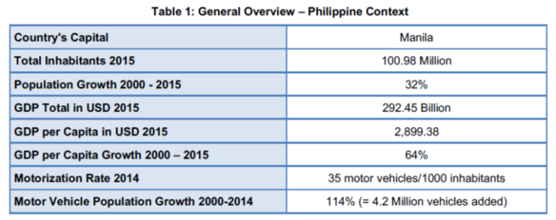

Approach for transformational change

***Maximum 1 to 1.5 pages***

***Guiding question:*** *WHAT**is planned exactly and HOW will the action change the sector?*

***Summary of*** *Sections 4.1 to 4.5*

Create a narrative for transformational change showing how the different measures remove the barriers and how the intended changes will lead to a significant and permanent transformation towards a low carbon pathway (theory of change).

Mention the overall and specific objectives including quantitative targets, clarify the scope / limits of the action, and describe its main measures including (a) direct GHG mitigation measures and (b) supporting measures / soft measures.

Present a figure with the barriers, measures and objectives (see **Example figure** below).

Describe main partners, phases, and the scheduling of different elements of preparation and implementation of the action (see **Example figure** below).

Highlight links with / contribution to implementation of national climate / sector policies and other relevant initiatives

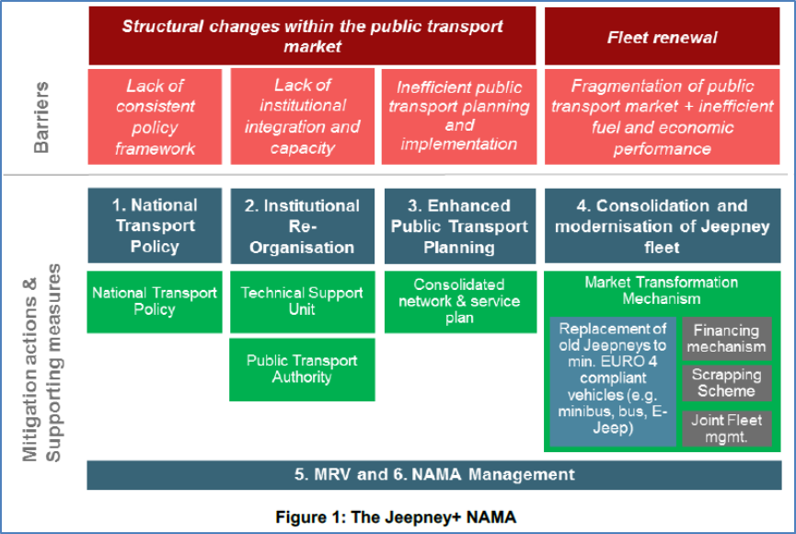

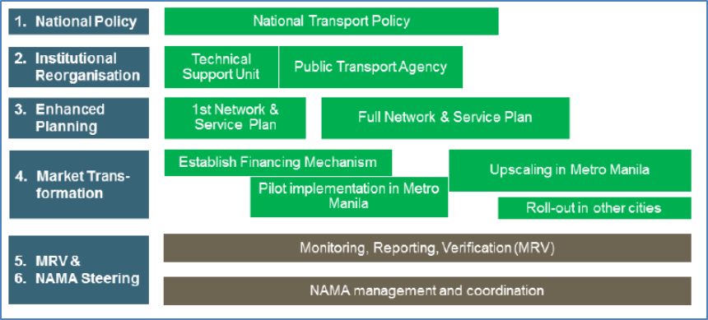

Expected benefits: GHG mitigation and more!

***Maximum 1 to 1.5 pages***

***Guiding question:*** *WHAT impacts do we expect? (GHG + sustainable dev. benefits)*

***Summary of*** *Sections 4.6*

Describe the estimated ex ante GHG mitigation impact for different scenarios and use a table to display numbers in an easy to understand manner.

Briefly describe most relevant assessment boundaries (gases, geographical aspects, etc.), data quality and main elements and assumptions in BAU and mitigation scenarios.

***Example:*** *The calculation of the ex ante GHG mitigation potential and the estimation of the sustainable development benefits is based on the following scenarios and main assumptions (further details in Section 6):*

* Baseline Scenario (BAU): mention main assumptions
* Scenario 1 “##simple name”: mention main assumptions
* Scenario 2 “##simple name”: mention main assumptions
* Scenario 3 “##simple name”: mention main assumptions

Use a table to present core results (see **Example**).

|  |  |  |  |  |
| --- | --- | --- | --- | --- |
| Scenario | BAU | Conservative / Low | Realistic / Medium | Optimistic / High |
| Total GHG over 10 years (20Xx-20YY) | X MtCO2e | X MtCO2e  (equal to –X% compared to BAU) | X MtCO2e  (equal to –X% compared to BAU) | X MtCO2e  (equal to –X% compared to BAU) |
| Average GHG mitigation |  | X MtCO2e / a | X MtCO2e / a | X MtCO2e / a |
| Mitigation in 20YY |  | X MtCO2e / a | X MtCO2e / a | X MtCO2e / a |
| % of transport emissions in 20YY |  | X % | X % | X % |
| % of NDC transport target in 20YY |  | X % | X % | X % |
| Other benefits: xxx |  |  |  |  |

Explain the contribution to NDC implementation and make sure to mention **mandatory core numbers** to help the reader understand the relevance of the mitigation action.

***Example with mandatory numbers:*** *In its Nationally Appropriate Contributions (NDC), Colombia has pledged to reduce its Greenhouse Gas (GHG) emissions by 20% with respect to the projected Business-as-Usual Scenario (BAU) by 2030 (30% with international support). In 2012, total GHG emissions in Colombia were X MtCO2. The transport sector was responsible for 36% of energy-related emissions (equivalent to 28.2 MtCO2eq). Transport is expected to emit about 48.6 MtCO2eq in 2030 (IDEAM, 2016), due to rapid growth of cities and individual motorized transport.*

*The mitigation action described in this document is expected to achieve accumulated GHG emission reductions in the range of XX to XX MtCO2e over 10 years between 20xx and 20xx (##Attention: Make sure to present accumulated over 10 years!). This translates into an average annual GHG emission reduction of X to X MtCO2e and X MtCO2 in 20xx (##year 10 or e.g. NDC target year). The implementation of the mitigation action will reduce the total yearly transport GHG emissions in ##name of country## by X% and contribute with X MtCO2 or XX% to achieve the NDC target for the transport sector of minus X MtCO2 in 20XX or accumulated until 20XX. The following table summarises the core numbers for the ##two / three## different scenarios compared to the baseline scenario.*

Summarize qualitatively and quantitatively the most important sustainable development benefits.

Mention numbers / order of magnitude wherever available. Make sure numbers are understandable (use comparisons to facilitate comprehension)

**Example:** The mitigation action will generate various benefits besides GHG emission reductions. The improvement of public transport services is expected to result in reduced congestion and travel time, better quality of public transport service, and improved road safety. The shift towards more efficient low emission vehicles will improve air quality and contribute to fuel security by reducing fuel demand. Consolidation and joint fleet management is expected to realise better working conditions for providers of public transport services.

The modernization of the jeepney fleet in Metro Manila, combined with the rationalization of public transport services in major corridors would result in total on-road diesel savings between 528 to 754 million litres (up to 2026) or 310 million to 443 million USD. If the impacts of the scaled up jeepney modernization program (nationwide) are included, the total amount of diesel to be saved can be between 1.9 to 2.7 trillion litres (or 1.9 to 2.7 billion per year) or 1.1 to 1.5 trillion USD.

It is estimated that the mitigation action will reduce harmful air pollutant emissions such as Particulate Matter (up to 47%), Carbon Monoxide (up to 52%), NOx (up to 30%), SOx (up to 9%) and Hydrocarbons (up to 52%). The reduction in the emissions of these pollutants is estimated to positively impact the health of the citizens. The estimated human toxicity impacts are estimated to be reduced by 53%. The monetized health value of the reduced air pollutants in Metro Manila are estimated to be between 83 to 119 million USD per year. If the scaled up program for the jeepney technology modernization is accounted for, the monetized value of air pollution reduction is estimated to be in the range of 220 to 316 million USD p.a.

Financing concept

***Maximum 1 page***

***Guiding question:*** *Who will pay what when and how do costs relate to economic benefits?*

***Summary of:*** *Sections 5.2 to 5.5 (no need to summarize 5.1)*

Describe the main results of the financial and economic viability analysis (incl. analyzed cases, main assumptions and core results).

Use these results as a justification for the financial mechanism / structure and describe its design and how financing the action will work. Explain this along the financial flow chart.

Describe scale of investment and support needs. Show total size of investments needed, what is secured already and the remaining financial gap. Highlight opportunities for private sector international donors.

Use selected figures and tables from Section 5.

You might want to include a summary figure like this highlighting financial, GHG mitigation and transformational ambition in a single figure.

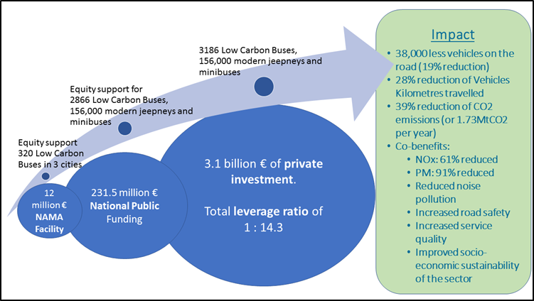

1. Introduction

**Maximum 1-2 pages**; otherwise many overlaps with following sections. So, be short!

**Objective:** Help the reader understand right at the beginning why this mitigation action is the right thing to do. **Why** is this mitigation action important? This section will not give detailed information about the mitigation action itself.

Start with an **easy to understand** **convincing narrative** **(*storytelling approach*)**. Describethe motivation to put forward the mitigation action including a snapshot of sector context and country ownership.

***Example:*** *“Traffic rules it all. There is no bigger topic in the daily urban life of the Philippines than traffic. Everyone who is living or who has visited Manila understands why. Commuting times have reached unprecedented levels and the traffic jams on EDSA are world-known. Many factors played into this: The Philippines is one of the fastest growing economies in East Asia, almost tripling its Gross Domestic Product (GDP) in the last 10 years.* *Road-based public transport system lacks state-of-the-art technologies and operational procedures. Where Manila has too few high-capacity railway lines it has too many smoke-belching buses and jeepneys. It is believed that there are much more jeepneys plying the streets of Metro Manila than the 54,800 officially registered vehicles. In a highly liberalized market, buses and jeepneys are competing on-street over customers, which has led to dangerous traffic situations and is significantly contributing to traffic. The cost of congestion in Metro Manila alone translates to an estimated loss of 20 billion USD annually, which is around 7.4% of the country’s GDP. The government recognizes that modernising public transport is an overdue priority for economic and social prosperity and for the ecological footprint of the sector. This recognition is reflected in the National Environmentally Sustainable Transport Strategy (NESTS) and …. Main actions planned include: xxx, xxx, and xxx.”*

Use a **photo** and an **illustration / figure** showing trends over time to underline your message.

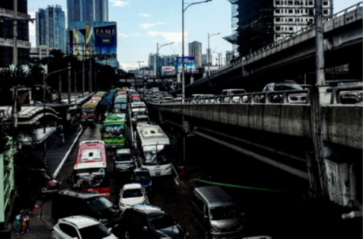

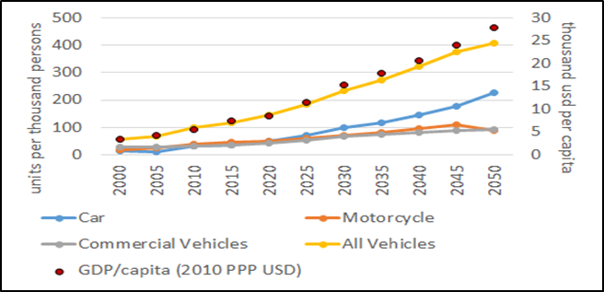

Briefly describe **main idea** and mention **components** of the mitigation action (bundle of actions):

* Mention main barriers / challenges regarding the switch to a low carbon path and the measures foreseen to address these barriers / challenges (name direct mitigation measures e.g. fleet renewal and supportive measures e.g. regulation of xx, capacity building for xx).
* Outline mid-/long-term vision and transformational ambition (overall objective).
* Describe your approach with reference to the Avoid–Shift–Improve approach.
* Name involved governmental institutions and main partners.
* Mention current state of development of the mitigation action. Clarify the scope of the action and its limitations (eventually covered by other initiatives or intentionally left out).

Use **at least one figure or table** (e.g. on general idea or phases, example below).

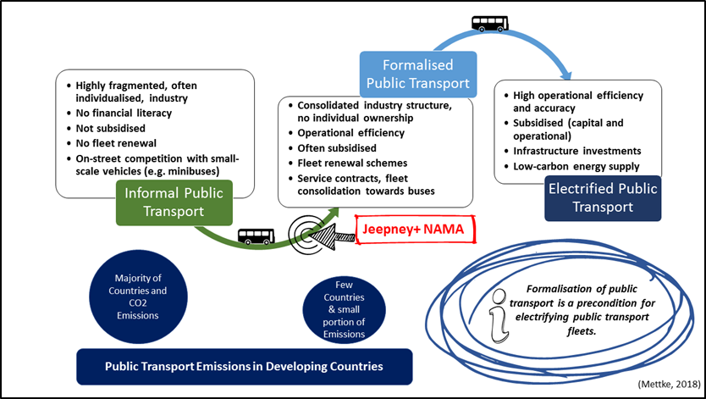

1. Sector overview: [insert Mitigation Action name and country, e.g. Public Transport in Colombia]
   1. Relevance of the (sub-)sector

***Maximum 2 pages***

Highlight sector relevance – present numbers!

* economically / socially (relevance for the economy, proportion of GDP, sector turnover, number of vehicles and number of involved companies and families and jobs depending on the sector, quality of life, accessibility, road safety, …)
* transport / mobility relevance / performance (use key indicators to characterize the (sub-)sector e.g. modal split; average speed; fuel efficiency; etc.; use tables and figures to highlight important drivers and trends such as growing motorization with numbers (vehicle stock, its growth rate, motorization rate per 1000 inhabitants), put numbers in context (mentioning numbers for other countries)
* environmentally (local air pollutants and GHG emissions; **it is a must to mention the following numbers** incl. year and source:
  + total GHG emissions in the country
  + total energy related GHG emissions in the county and its % of the total
  + total transport GHG emissions and its % of total and energy related emissions
  + total GHG emissions of the subsector addressed by the mitigation action and its % of transport GHG emissions
  + numbers of important drivers for growing emissions (e.g. increasing motorization rate)
  + Text example: *In its Nationally Appropriate Contributions (NDC), Colombia has pledged to reduce its Greenhouse Gas (GHG) emissions by 20% with respect to the projected Business-as-Usual Scenario (BAU) by 2030 (30% with international support). In 2012, total GHG emissions in Colombia were X MtCO2. The transport sector was responsible for 36% of energy-related emissions (equivalent to 28.2 MtCO2eq of a total of X MtCO2 of energy related emissions) and transport is expected to emit about 48.6 MtCO2eq in 2030 (IDEAM, 2016), due to rapid growth of cities and individual motorized transport.*
* in all areas: show status quo and historic development, trends and projections over time
* Underline negative impacts of current situation and foregone benefits in general terms
  1. Transport and climate policy context

***Maximum 2 pages***

Describe relevant transport sector policy, regulation and programmes and their mitigation ambition (mention core policy documents incl. specific targets).

Describe the national climate policy context, mitigation strategy and plans to address climate change, including Nationally Determined Contributions (NDC).

Mention the overall NDC target and if available sectoral transport target

Describe the NDC implementation process (who is responsible, what is the role of the line ministries, how is related budgeting and reporting organized, etc.).

Describe the linkage of the mitigation action to NDC and sector policy and illustrate how the mitigation action fits in the overall climate change and transport policy of the country.

Provide footnotes with weblinks to policy documents and indicate specific pages.

Example of a table with core policy documents:

|  |  |  |
| --- | --- | --- |
| Year | Policies, programmes and projects | Relevance |
| National laws | | |
| 2003 | National policy for urban and mass transport (SITM)  CONPES 3260 | Establishing a program offering financing and technical assistance to larger cities with the aim to implement high-quality public transport in the form of integrated massive transport systems. |

* 1. Governance, market organization and relevant stakeholders

***Maximum: 2.5 pages***

Give relevant information so that as well an international audience can easily capture the overall sector set-up and the role and importance of different players.

Describe how the market is currently structured (formal/informal, regulated, subsidized prices, oligopolistic or with many competitors).

Describe relevant market players (public, private, academia, civil society, national, state and local level); where possible and useful distinguish by market segment. Highlight linkages / relations / dependencies between segments and players

Use at least one tables or figure to illustrate relevant information (see examples below)

**Example information on market composition**

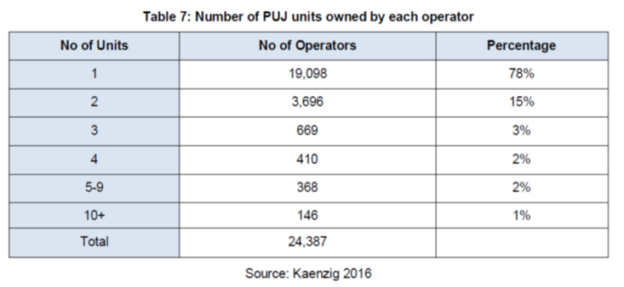

**Example stakeholder map**

Relevant stakeholders are shown in the figure below and divided into four categories:

* **Veto players:** actors whose support and participation are necessary in order to achieve the targeted results of the project or actors who may veto the project;
* **Key stakeholders:** actors directly involved in the decision-making of the project and who are able to strongly influence the implementation of the project;
* **Primary stakeholders:** actors directly affected by the implementation of the project;
* **Secondary stakeholders:** actors that are temporarily or indirectly involved in the implementation of the project.

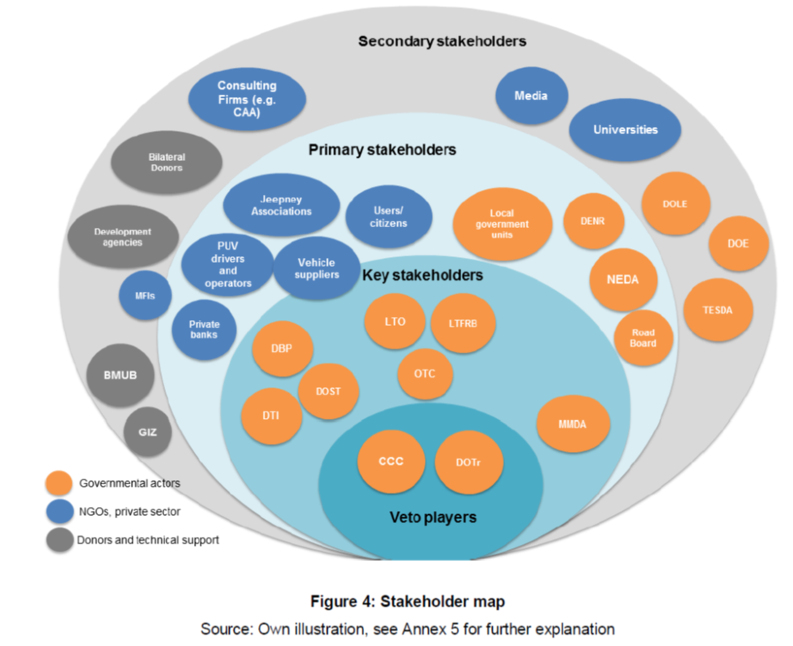

**Example: stakeholder roles and mandates**

See an example below and a further example here on page 22ff: <https://www.changing-transport.org/wp-content/uploads/2015_Capone_Velezmoro_FullConceptTransPeru.pdf>

|  |  |
| --- | --- |
|  | Roles and responsibilities with regard to the NAMA |
| Veto players | |
| Department of Transportation (DOTr) | The DOTr is the lead executing government agency responsible for public transport planning. In the context of the NAMA, the DOTr is the main implementing agency at the national level and is responsible for the overall design, planning, development and implementation of the NAMA. The DOTr forms part of the Political Board and is the Chair of the Technical Steering Committee of the envisaged NAMA Steering Structure. This signifies its key role in decision-making and its tasks of providing strategic guidance to the project and of mainstreaming the NAMA in all relevant political levels and the public. The DOTr is also expected to convene and moderate meetings of the Steering Committee, monitor and actively follow-up the implementation of the annual work plan for the NAMA. |
| Climate Change Commission (CCC) | The CCC is the lead policy-making body of the national government in the coordination, monitoring, and evaluation of climate change programs and action plans. The CCC is the overall lead in the implementation of the Philippine Greenhouse Gas Inventory Management and Reporting System, which signifies its role in providing direction and guidance to the DOTr in developing a GHG inventory system for the transport sector. This further enables the development of the MRV system to support the implementation and evaluation of the NAMA. Moreover, the CCC is the overall coordinator to the United Nations Framework Convention on Climate Change (UNFCCC) and is a part of the Political Board of the envisaged NAMA Steering Structure, which highlights its key role in decision-making and in mainstreaming the NAMA. |
| Key stakeholders | |
| Land Transportation Franchising and Regulatory Board (LTFRB) | The LTFRB is the attached agency of the DOTr responsible for issuing franchises that authorizes the operation of public transport services. Moreover, the LTFRB prescribes and regulates public land transport services for all routes in the country. In the context of the NAMA, this signifies its role in regulating the entry and operation of buses and jeepneys and in administering franchises to the modernised public transport vehicles for operation. The LTFRB also determines fare rates of public land transportation services. The LTFRB is also a part of the Technical Steering Committee, which highlights its role in providing inputs to the annual work plan for the NAMA. |
| Primary stakeholders | |
| Department of Environment and Natural Resources (DENR) | The DENR is the lead agency in the overall implementation of the Philippine Clean Air Act, which provides the policy framework for air quality management of the country and which addresses air pollution from the transport sector. The DENR also issued the Department Administrative Order No. 2015-14, which provides the full implementation of Euro 4 standards on new cars in 2016. Moreover, the DENR is an approving entity in terms of emission standards of new vehicles that could replace the jeepneys, which highlights the role of the DENR in the context of the NAMA. |

* 1. Finance and current business model(s)

***Maximum 2 pages***

This section and Section 3 “Barriers” contain the results of the financial context analysis (a standard element during the two years process to prepare a mitigation action under TRANSfer).

Describe market dynamics, current business models and the nature of investments in the (sub-)sector of the mitigation action (mainly public, private or mixed; who pays for what; how capable are current market players in financial terms? Creditworthiness? Willing and able to invest? Particularly in cases of a strong private sector role, describe the key characteristics and dynamics of the sector or market in which the mitigation action will operate.)

Describe the business environment and investment climate: How developed and robust are financial markets? Level of regulatory and political stability? How well are contracts with public and private sector actors enforced?)

Mention the main financial actors and relevant financial flows (Who are the main financial actors in the sector today? What is the role of commercial banks and development banks?).

Private sector: Role of the private sector in the sector today. Could its role be strengthened?

National public funding: How much of the national public budget does the sector receive today? How is public funding allocated (steps, deadlines)? Current budget distribution by budget items? What public funding and financing mechanisms are in place, e.g. subsidy mechanisms, mechanisms to transfer funding from the national to the sub-national levels? Mention financial volume of these.

* 1. Related initiatives

***Maximum 1.5 pages***

Mention main donors in the sector and describe other projects/activities in the sector the mitigation action relates to or builds on; not only international cooperation but as well local initiatives.

Mention potential overlaps, planned cooperation and synergies.

Briefly explain the additionality of the mitigation action described in this concept document.

Give information on the other initiatives: name, objective, intended benefits, involved institutions, lead implementing agencies, numbers to illustrate magnitude (budget, number of partners, expected / achieved impacts, etc.), current and future scope. You might want to use a table for this purpose (see example below).

|  |  |  |  |
| --- | --- | --- | --- |
| Programme / Project | Supporting international agencies | Relevance for TA and TDM | Budget |
| FINDETER | | | |
| The Emerging and Sustainable Cities Program (ESC) | Implementing agency: FINDETER, in the frame of the BID Initiative  Allies: CAF, AFD[1] | Interdisciplinary approach towards addressing the most urgent challenges of medium-sized cities. Following a thorough analysis of the needs of participating cities, the program defines an action plan and prioritizes topics, one of them being mobility. Example activities include:  Urban Mobility Master Plans  Studies and technical designs that includes cycle-infrastructure and parking schemes | 500 million USD |

1. Barriers to decarbonizing / to a low carbon [insert Mitigation Action name and country]

***Maximum 4 pages***

**Important note:** This chapter is methodologically important because the barriers outlined here (Chapter 3) form the basis of your impact chain / theory of change (Chapter 4). The measures described in Chapter 4 need to be linked logically and build directly upon the barriers. Use figures to underline this relation: in Chapter 3 only with the barriers and then an extended figure in Chapter 4 with barriers and measures.

**Example**

* Chapter 3 on barriers



* Chapter 4 on the measures constituting the mitigation action

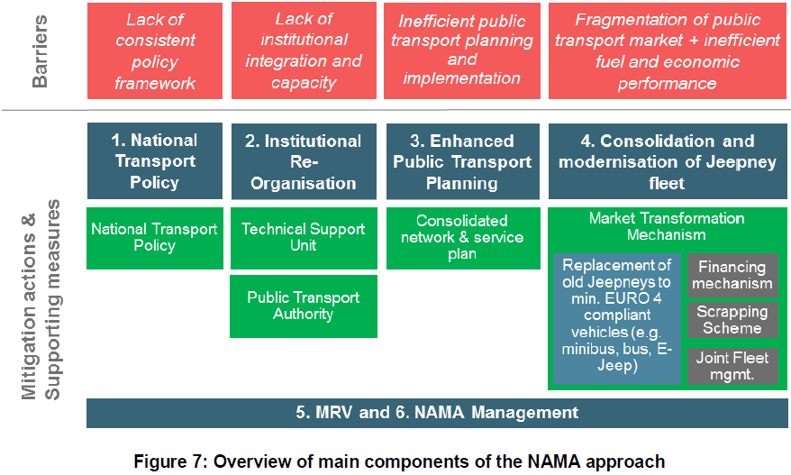

Answer the overarching question: what does currently prevent the changes needed to embark on a low carbon pathway to happen?

Describe the main root causes and barriers that need to be addressed.

Do present only barriers relevant for the specific mitigation action, not for the sector as such.

Include an introductory paragraph followed by details for certain barriers in different categories (not all categories might be relevant in all cases; pick from the ones listed below)

**Example:**

*Currently, several barriers inhibit efficient public transport operation in the Philippines (shown in Figure 6). These barriers are especially related to the fragmented industry structure, weak institutional structures and the lack of capacity for planning, implementing and enforcing state-of-the art public transport principles. Four main barriers have been identified: (social, gender, fiscal, regulatory, technological, financial, ecological, institutional, etc.).*

Political barriers

##complete

Regulatory barriers

##complete

Institutional barriers

##complete

Financial and fiscal barriers

##complete

Social, cultural and awareness barriers

##complete

Lack of knowledge, capacity

##complete

Technological barriers

##complete

MRV related barriers

##complete

**Example** table to summarize barriers

|  |  |  |  |
| --- | --- | --- | --- |
| Political barriers | xxx | Regulatory barriers |  |
| Institutional barriers |  | Financial and fiscal barriers |  |
| Lack of knowledge, capacity and awareness |  | Technological barriers |  |
| Social, cultural and awareness barriers |  | MRV related barriers |  |

1. The Mitigation Action

**Important note:**

According to TRANSfer’s methodology a mitigation action consists of 3 types of measures:

* **(1) Direct mitigation measures**, i.e. those measures that do actually mitigate GHG emissions, e.g. bus scrapping (see 4.3 GHG mitigation actions)
* **(2) Supportive measures**, i.e. measures that do not mitigate emissions but are required to ensure that the direct GHG mitigation measures do actually work. In that sense supportive measure sort of “enablers” for direct GHG mitigation measures, e.g. training of workers at a scrappage plant, etc. In general, these measures include individual and institutional capacity development and improvement of framework conditions (see 4.4. supportive actions).
* **(3) Organizational measures** (the implementation arrangement for process coordination and project management), i.e. measures for sound management and coordination of the overall process to implement the mitigation action.

This chapters needs to show clearly that the measures constituting the mitigation action are the correct measures to overcome the barriers mentioned in Chapter 3. The following figure illustrates the relationship between barriers and the three types of measures.

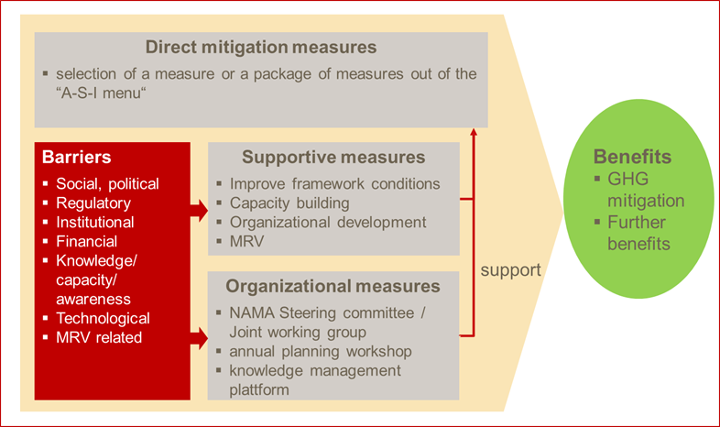

* 1. Objective and concept

***Maximum 2 pages***

Describe the objective of the mitigation action in a **single**, easy to understand sentence.

Present indicators and quantitative targets.

Provide an overview of the structure of the mitigation action (objective / outcome, outcome indicators, components / outputs / specific objectives). Use a figure to illustrate the structure (see examples below).

Explain the theory of change behind the concept in a general, easy to understand way (verbal explanation of the log-frame) including a reference to A-S-I paradigm and a rough description of the main phases and duration of preparation / implementation. Highlight – with reference to the barriers – the kind of incentive(s) (regulatory or financial) needed to make the changes happen in the market and/or to motivate users/investors to use or buy a new technology or change their behavior.

**Example 1 - Philippines:** The objective of the Jeepney+ NAMA is to establish a modern, sustainable and climatefriendly road-based public transport system in Philippine cities. The reform process envisaged by the Government involves key structural changes during an implementation period of approximately 10 years (2016-2026). The strategy is based on two main elements: (1) Structural changes within the public transport market (details in bullets), (2) Fleet renewal incl. shift to higher capacity vehicles (details in bullets). The NAMA is a combination of shift and improve approaches to reduce emissions from the transport sector and tackles different arenas of the public transport market (see Figure 7). Ultimately, the NAMA aims to consolidate public transport provision towards a manageable number of public transport service providers/companies.

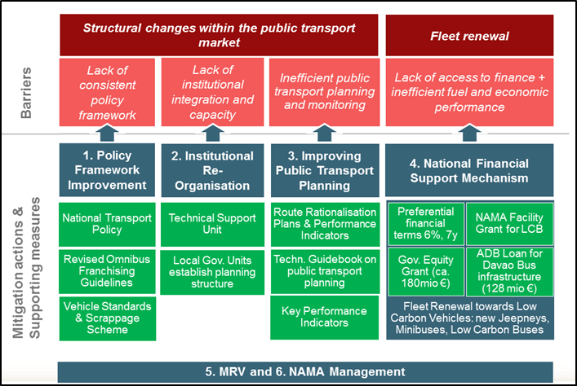

**Example 2 - Colombia:** The overall objective of the NAMA is to increase the use of cycling and to rationalize the use of private motorized modes, thereby improving the quality of life of the urban population and contributing to the mitigation of climate change. Main indicators for achieving these goals are:

* 1) increase in modal share of cycling by 9% until 2030 in the cities subject to the NAMA,
* 2) accumulated investment (public and private) into AT and TDM of US 900m until 2030,
* 3) significantly improved regulatory framework conditions, indicated by at least 10 changes in regulation facilitating projects in AT and TDM,
* 4) reduction of at least 3.88 MtCO2 accumulated over the period 2017 - 2030.

The NAMA comprises eight direct mitigation measures in the field of AT and TDM (see chapter X for further detail), to be implemented by the local level, as well as a NAMA Support Component to be implemented by the national level, which provides capacity building, technical advisory and promotion activities to the cities (see chapter X for further detail) and improves the overall regulatory framework. It is assumed that the implementation of the NAMA Support Component alone will yield a significant increase in the implementation of AT and TDM measures in Colombian cities, as the major hurdle towards the implementation of the NAMAs 8 direct mitigation measures is seen in the lack of local capacities and know how on benefits and technical aspects, as well as gaps in the regulatory framework. Financial support by third parties to the local level will further facilitate and speed up the implementation of the eight mitigation measures. In order to achieve a significant modal shift towards cycling, the NAMA employs a comprehensive Push and Pull Approach. On the one hand, it aims at incentivizing active modes, such as conventional and electrically assisted bicycles and tricycles, e.g. by providing an adequate infrastructure or other benefits to cyclists, and thereby attracts additional AT trips (“Pull”). On the other hand, it discourages the use of individual motorized modes, e.g. by constringent parking policies and thereby pushes demand from motorized modes towards the more sustainable, non-polluting active modes (“Push”).

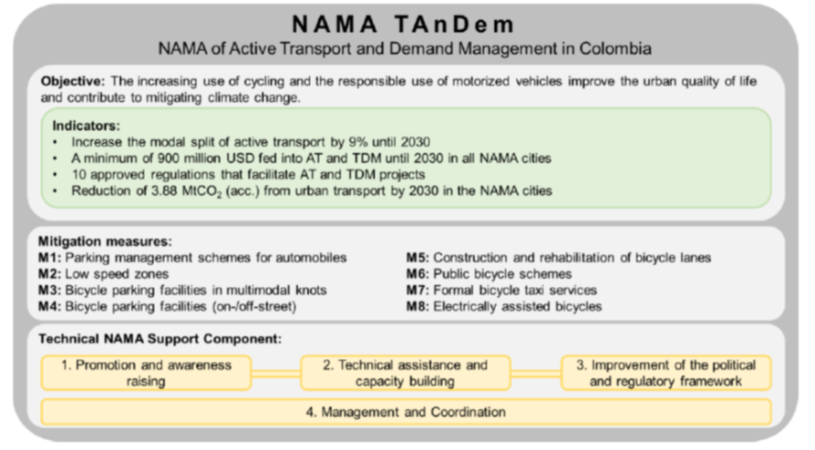

Present core facts about the mitigation action in a standard summary table. **Example:**

Table 2: The Mitigation Action at a glance

|  |  |  |  |
| --- | --- | --- | --- |
| Contribution to NDC implementation | ##specify | | |
| Type of action | Policy / Programme / Regulation / Economic instrument / Etc. | Subsector | e.g. road based public transport, all modes |
| Geographical scope | e.g. full country, certain regions; medium sized cities; specific cities X, Y, Z | Type of policy instruments | Regulations: yes / no  Economic instruments: yes / no  Public spending/ investments: yes / no  Communication and information: yes / no |
| Organisation | Responsible organization: xxx  Involved national partners: xxx  Involved international organizations: xxx | | |
| Main mitigation measures | (1) xxx ##take information from chapter 4.3  (2) xxx  (3) xxx | | |
| Schedule | **Phase 1:** “Preparation” (2013-2014)  **Phase 2:** “Improvement of framework conditions, pilot-testing of programs and generation of good practice / showcases” (2015 – 2017)  **Phase 3:** Full scale implementation (2017 onwards, partly in parallel to phase 2) | | |
| GHG mitigation effect and other benefits | GHG mitigation: X MtCO2e between 20xx and 20xx (always over 10 years!!!); average annual mitigation X MtCO2e  Other beneftis: xxx | | |
| Feasibility | Financial feasibility: ##provide information re micro-economic feasibility and eventually details on required incentives  Economic feasibility: ##provide quant. estimation of economic benefits, CBA ratio, etc. | | |
| Type of required support | Technical support: xxx  Financial support: xxx | | |

* 1. Scope

***Maximum 1 page***

Explain what the mitigation action covers and what goes beyond its borders.

The description of the scope is unique for every mitigation action; an action might be limited timewise, geographically, by types of emissions / gases covered, by sectors/ subsectors and or transport modes, by technologies and by many other factors.

* 1. GHG mitigation actions (direct mitigation measures)

***Maximum 5 pages***

This is one of the most important sections of the document since various other sections refer to this section (e.g. MRV, financing, etc.).

Describe planned direct mitigation measures, i.e. those measures that will contribute directly to mitigate GHG emissions.

Briefly mention the linkages and synergies between different actions leading to higher emission savings (e.g. public transport + congestion charging).

Include a table and/or a figure to illustrate planned actions.

* 1. Supportive actions (framework conditions, capacity development)

***Maximum 4 pages***

Describe the supportive actions / measures, i.e. those measures needed to overcome the barriers (Section 3) and to make the mitigation measures work,

Supportive actions / measures include measures to strengthen individual and institutional capacities and to improve the political, legal and regulatory framework conditions (= system capacities).

Please find below a possible but certainly not the only way to categorize these measures.

**Example text:**

To ensure that the implementation of the direct GHG mitigation measures works and to overcome the barriers outlined in chapter 3, several adjustments to the political, legal and regulatory framework conditions are required and capacities need to be strengthened in the following areas: xxx, xxx, xxx. The table in Section 4.6 “Action Plan” gives an overview of the planned supportive actions and the following text outlines the measures in more detail.

Political, legal, regulatory framework

Brief description and justification of actions / measures needed

Capacity development and technical assistance

Brief description and justification of actions / measures needed

Make sure to consider both individual capacities as well as institutional capacities / organizational development.

* 1. Implementation arrangement (organizational measures)

***Maximum 2 pages***

Agreeing on an implementation arrangement or steering structure among the core stakeholders is essential for efficient and effective management and coordination and thus for successful implementation of the mitigation action.

The following tool from the TRANSfer Project’s Toolbox gives guidance. <http://transferproject.org/wp-content/uploads/2016/12/NYP_GIZ_TRANSfer_Tool-1-4-2_NAMA-Coordination-Steering-Structure_08112016.pdf>.

Typically, a Steering Structure distinguishes (explicitly or implicitly) three levels with different tasks. Some typical tasks are outlined below:

* Political / strategic level: Give strategic guidance, take strategic decisions, approve budget, work plan and annual report / progress reports, representative tasks
* Management level: Prepare work plan, implement MRV system, coordinate mitigation action implementation, prepare annual report / progress reports, outreach
* Operational level: Implement specific tasks of the work plan, report to management level

Describe WHO is involved, WHAT his role is, WHICH groups / bodies are established and HOW coordination and management is supposed to work.

Include a figure with an organigram.

**Examples** can be found here:

* Peru, pdf pages 25 and 46: <https://www.changing-transport.org/wp-content/uploads/2014_Henkel_etal_FullConeptNAMASUTRI.pdf>
* Colombia, pdf page 59 / document page 69: <https://dms.giz.de/dms/llisapi.dll/link/226722013>
* Indonesia, pdf page 38 / document page 30: <https://www.changing-transport.org/wp-content/uploads/2014_Henkel_etal_FullConeptNAMASUTRI.pdf>
* Philippines, pdf page 59 / document page 50: <https://www.changing-transport.org/wp-content/uploads/2016_Full_NAMA_Concept_Jeepney_NAMA.pdf>
  1. Transformational change

***Maximum 1.5 pages***

***Guiding questions:*** *How will the mitigation action permanently change the sector?*

Describe the potential for transformational change:

* How will intended changes lead to a transformation towards a low-carbon pathway? Will the mitigation action achieve a sustainable transformation of a market or (sub-) sector in the country? Is the change irreversible?
* Catalytic effect: What developments / regulations are triggered in order to accelerate or initiate sector development towards a low-carbon pathway?
* Sustainability: How will the mitigation action significantly and permanently reverse the flow of funds (public budget, private investments) towards a low-carbon path?
* Replicability/scalability: Does the mitigation action enable a scaling up on national level or in several regions of the country?
  1. Action plan

Optional section

***Maximum 1 page***

Present an implementation plan in a standard workplan / gantt chart format.

**Example:** The structure of the table below can be used and expanded to include the schedule.

Table 3: Name of Table

|  |  |  |  |  |  |  |  |  |  |  |  |  |  |  |  |  |  |
| --- | --- | --- | --- | --- | --- | --- | --- | --- | --- | --- | --- | --- | --- | --- | --- | --- | --- |
| No. | Measure | Year 1 | | | | Year 2 | | | | Year 3 | | | | Year 4 | | | |
| (I) GHG mitigation actions | | Q1 | Q2 | Q3 | Q4 | Q1 | Q2 | Q3 | Q4 | Q1 | Q2 | Q3 | Q4 | Q1 | Q2 | Q3 | Q4 |
| 1.1 |  |  |  |  |  |  |  |  |  |  |  |  |  |  |  |  |  |
| 1.2 |  |  |  |  |  |  |  |  |  |  |  |  |  |  |  |  |  |
| (II) Supportive actions | |  |  |  |  |  |  |  |  |  |  |  |  |  |  |  |  |
| Political, legal and regulatory framework | |  |  |  |  |  |  |  |  |  |  |  |  |  |  |  |  |
| 2.1 |  |  |  |  |  |  |  |  |  |  |  |  |  |  |  |  |  |
| 2.2 |  |  |  |  |  |  |  |  |  |  |  |  |  |  |  |  |  |
| Capacity building and technical assistance | |  |  |  |  |  |  |  |  |  |  |  |  |  |  |  |  |
| 3.1 |  |  |  |  |  |  |  |  |  |  |  |  |  |  |  |  |  |
| 3.2 |  |  |  |  |  |  |  |  |  |  |  |  |  |  |  |  |  |
| (III) Implementation arrangement (coordination and project management) | |  |  |  |  |  |  |  |  |  |  |  |  |  |  |  |  |
| Steering Committee | |  |  |  |  |  |  |  |  |  |  |  |  |  |  |  |  |
| 4.1 |  |  |  |  |  |  |  |  |  |  |  |  |  |  |  |  |  |
| 4.2 |  |  |  |  |  |  |  |  |  |  |  |  |  |  |  |  |  |
| MRV | |  |  |  |  |  |  |  |  |  |  |  |  |  |  |  |  |
| 5.1 |  |  |  |  |  |  |  |  |  |  |  |  |  |  |  |  |  |

* 1. Risk assessment

***Maximum 1 page***

Optional section regarding publication but in any case useful for project management.

Present the main risks for implementation, their seriousness, the ability to influence the risks and possible risk mitigation measures in the table below.

It is important to understand that risks are different from barriers. Barriers are addressed directly by the measures planned under the mitigation action, whereas risks are external conditions that can materialize and will influence implementation.

**Example**

|  |  |  |  |
| --- | --- | --- | --- |
| Risk | Seriousness | Influence ability | Possible risk mitigation actions |
| Continuity despite of change in local / national government or other external factors | high | medium | Ensure that the NAMA is fully agreed and understood by public and private partners as an important priority for the country by quantifying and communicating expected costs and benefits. |
| Failure to establish the Metropolitan Transport Authority of Lima and Callao | medium | low | Early engagement of all stakeholders involved;  Transfer of good practice;  Promote alternative coordination mechanisms. |
| Failure to effectively engage the private sector | medium | high | Proactively private sector involvement from an early stage incl. preparation for upcoming changes |
| Failure to effectively engage urban inhabitants | medium / high | high | Use proper regulation, incentives and high-quality infrastructure to convince inhabitants;  Strong, clear engagement from the Government |
| Failure to mobilise sufficient funding for the implementation of the full matrix | high | medium | Clear and convincing communication strategy based on quantified costs and benefits  Diversification and proactive structuring of financial needs |

1. Financing concept

This section (Section 5) builds upon previous sections (Sections 4.3-4.5) and focusses on the design and justification of the specific financial structure for the mitigation action.

The current situation (financial context analysis) regarding financing in the (sub-)sector, existing business models and financial barriers are presented in Section 2.4 “Finance and current business model(s)” and Section 3 “Barriers”.

Review the Transport NAMA Handbook chapter on financing for the underlying approach. <https://www.changing-transport.org/wp-content/uploads/2015_Eckermannetal_NavigatingTransportNAMAsHandbook.pdf>

Write an introductory paragraph recalling briefly the main points from Sections 2.4 and 3.

* 1. Overview of costs and revenues

***Maximum 3 pages***

***Guiding questions:*** *What do the components of the mitigation action cost? Which revenues can we expect?*

Describe the costs and revenues for the different outputs / components. The presentation depends very much on the specific case and content stems from detailed financing studies.

Include CAPEX and OPEX. Consider costs for personnel, consulting services, procurement of goods/equipment/hardware, running costs, financing costs, overheads and profit margin.

Consider costs and revenues associated with the different types of actions / measures of the mitigation action:

* GHG mitigation actions,
* supportive actions (framework conditions, capacity development)
* activities for management and coordination (organizational measures).

Assess the option to present costs in the same structure as in the action plan (see table below):

|  |  |  |  |  |
| --- | --- | --- | --- | --- |
| No. | Measure | CAPEX (Euros, total) | OPEX (Euros p.a.) | Revenues (Euros p.a.) |
| (I) GHG mitigation actions | |  |  |  |
| 1.1 |  |  |  |  |
| 1.2 |  |  |  |  |
| 1.3 |  |  |  |  |
| Total | |  |  |  |

|  |  |  |  |  |  |  |
| --- | --- | --- | --- | --- | --- | --- |
| No. | Measure | | Personell  (Euros  p.a. or total) | Consulting services (Euros  p.a. or total) | Procurement of goods (Euros  p.a. or total) | Running costs (Euros  p.a. or total) |
| (II) Supportive actions | | |  |  |  |  |
| Political, legal and regulatory framework | | |  |  |  |  |
| 2.1 | |  |  |  |  |  |
| 2.2 | |  |  |  |  |  |
| 2.3 | |  |  |  |  |  |
| Capacity building and technical assistance | | |  |  |  |  |
| 3.1 | |  |  |  |  |  |
| 3.2 | |  |  |  |  |  |
| 3.3 | |  |  |  |  |  |
| (III) Implementation arrangement (coordination and project management) | | |  |  |  |  |
| Steering Committee | | |  |  |  |  |
| 4.1 | |  |  |  |  |  |
| 4.2 | |  |  |  |  |  |
| 4.3 | |  |  |  |  |  |
| MRV | | |  |  |  |  |
| 5.1 | |  |  |  |  |  |
| 5.2 | |  |  |  |  |  |
| Total | | |  |  |  |  |

**Example:**

Table 4: Average unit costs and revenues of TAnDEm’s direct mitigation measures[2]

|  |  |  |  |  |
| --- | --- | --- | --- | --- |
| No. | Measure and unit | Investment cost  [USD] | Operation and maintenance [USD/year] | Revenues  [USD/year] |
| M1 | Parking space management schemes for automobiles (area with 15,000 parking spots) | **1.5 million**  (500 parking meters, signage and information systems) | **3 million**  (control staff of 70 people and O&M of parking meters) | **4.2 million**  from parking fees and fines |
| M2 | Low-speed zones (1 km2) | **20,000**  (including studies, 6 vertical and horizontal signage, 28 plastic speed humps, 10 bicycle parking spaces) | **negligible** | **negligible**  (fines from radar control) |

**Example:**

Box 1: Average cost of NAMA implementation in larger cities – Example of Cali

|  |  |  |  |  |  |  |  |  |  |  |  |  |  |  |  |  |  |  |  |  |  |  |  |  |  |  |  |  |  |  |  |  |  |  |  |  |  |  |  |  |  |  |  |  |  |  |  |  |  |  |  |  |  |  |
| --- | --- | --- | --- | --- | --- | --- | --- | --- | --- | --- | --- | --- | --- | --- | --- | --- | --- | --- | --- | --- | --- | --- | --- | --- | --- | --- | --- | --- | --- | --- | --- | --- | --- | --- | --- | --- | --- | --- | --- | --- | --- | --- | --- | --- | --- | --- | --- | --- | --- | --- | --- | --- | --- | --- |
| The total investment costs for the **Conservative Scenario** account for 49 million USD, annual operating and maintenance costs (O&M costs) make up approximately 2 million per year.[3] In the **High Shift Scenario** total investment costs account for 83 million USD, while annual O&M costs make up approximately 4 million per year.[4] In comparison, Cali’s overall household budget for 2017 is 1 billion USD and the planned expenditure in sustainable mobility between 2016 -2019 is 611 million USD, meaning that **NAMA implementation costs approx. 0.6 -1.0% of Cali’s annual household budget or 3.8 – 6.7% of the 4 year expenditure plan for SUT**. It has to be noted that costs for electrically assisted bicycles and revenues resulting from potential radar speed control are not yet considered in the calculation.   |  |  |  |  | | --- | --- | --- | --- | | **NAMA measures** | | **Scope of measures (2018 -2030)** | | | **Conservative Scenario** | **High Shift Scenario** | | **M1** | Parking space management schemes for automobiles | not defined | | | **M2** | Low-speed zones | 1.5 km2 | 2 km2 | | **M3 and M4** | Bicycle parking spaces in multimodal nods and Private bicycle parking spaces | 14,000 units  (5,000 inverted U and 9,000 integrated in BRT system) | 19,000 units  (7,000 inverted U and 12,000 integrated in BRT system) | | **M5** | Construction and rehabilitation of bicycle lanes | 300 Km (only segregated) | 450 Km (only segregated) | | **M6** | Public bicycle systems (PBS) | 4,000 bicycles | 8,000 bicycles | | **M7** | Formal bicycle taxi services | 3,500 new units | 5,000 new units | | **M8** | E-bikes | not assessed | | | **Total cost (2018 - 2030)** | | **49 million USD** | **83 million USD** | | **Annual O&M cost** | | **2 million USD** | **3.9 million USD** | | **Household budget 2017** | | **1 billion USD** | | | **Percentage of household budget** | | **0.6%** | **1.0%** | | **Percentage of 4 year expenditure plan for SUT (2016 2019)** | | **3.8%** | **6.7%** | |

**Example:**

The cost purchasing a second hand jeepney with franchise can vary from PHP 270,000 (USD 5,425) to over PHP 500,000 (USD 10,046) depending on the characteristics and profitability of the franchised route, with a ‘typical’ franchise valued at around PHP 350,000 (USD 7,032). The jeepney unit is estimated to represent around PHP 200,000 (USD 4,018) of this overall value (although true market value of the unit is difficult to estimate given the lack of market for the unit without an associated franchise). By means of comparison, a newly built jeepney vehicle without franchise is estimated to cost in the region about PHP 650,000 (USD 13,060).

The operator is responsible for maintaining the vehicle. Maintenance tends to be carried out on a reactive rather than pro-active/preventative basis. The table below shows the estimated annual maintenance costs identified in the Jeepney Market Study. Industry feedback suggesting typical maintenance costs of PHP 50,000-65,000 (USD 1,005-1,306) per annum corroborate these figures.

Table 5: Annual maintenance cost of baseline jeepneys by route

|  |  |  |  |  |
| --- | --- | --- | --- | --- |
| Item | < 5 km | 5 - 10 km | 10 - 20 km | > 20 km |
| Engine Maintenance | PHP 8,344.5  (USD 167.6) | PHP 13,744.7  (USD 276.16) | PHP 26,037.6  (USD 523.2) | PHP 31,161.9  (USD 626.1) |
| Mechanical Maintenance | PHP 10,311.7  (USD 207.2) | PHP 16,985.0  (USD 341.3) | PHP 32,176.0  (USD 646.5) | PHP 38,508.4  (USD 773.7) |
| Total | PHP 18,656.3  (USD 374.9) | PHP 30,729.8  (USD 617.4) | PHP 58,213.6  (USD 1,169.6) | PHP 69,670.3  (USD 1,399.8) |

Source: Biona, 2015

Revenues for jeepney operation are generated by the carriage of fare paying passengers. Typical farebox revenues are in the region of PHP 3,000 to 4,000 (USD 60.28 to 80.37) per day depending on the route. This revenue does not all go to the operator however. The revenue received by the operator depends on the operating arrangements, and in particular whether the owner is an operator-driver or whether the unit is rented out.

Where the operator does not also drive (for example in the case of an owner of more than one unit) the income takes the form of a ‘boundary payment. Under the boundary system, the revenue to the operator is the rental value of the unit. The typical boundary value ranges from PHP 500 up to PHP 1,200 (USD 10.05 to 24.11) per day, dependent on the route characteristics.

* 1. Financial viability

***Maximum 2 pages***

***Guiding questions:*** *Is there**business case for the realization of the GHG mitigation actions? If not, what type and level of public support is needed to create a business case?*

Describe the approach taken / methodology used to evaluate the financial feasibility (micro-economic perspective, i.e. from the investor’s / user’s / operator’s perspective!).

Use a life-cycle approach and clarify boundaries of realized assessments.

Refer to and quote the detailed financing studies.

Describe the baseline case and the investment cases with clear, easy to understand names.

Where necessary present main results of sensitivity analysis from detailed financial studies.

Present a table with main data and assumptions as well justification of assumptions.

|  |  |  |  |  |
| --- | --- | --- | --- | --- |
| Parameter | Unit | Used value | Assump-tion | Source or justification of assumption |
|  |  |  | yes/no? |  |
|  |  |  |  |  |
|  |  |  |  |  |
|  |  |  |  |  |

NOTE: In case of measures without revenues (for the user), this Section is optional (e.g. cycling lanes), since realizing a financial feasibility analysis is not possible.

* 1. Economic viability

**Maximum 2 pages**

**Guiding questions:** Why should the mitigation action be supported with public resources? Which quantitative / monetized benefits can we expect beyond the CO2 impact?

Review Transport NAMA Handbook Section 3.4.1 (2.5 pages) to get a quick introduction.

This section shows if the mitigation action is worthwhile from an overall societal point of view. Many transport measures have a poor financial performance (micro-economic) without government support. Thus, the private sector alone would not finance the action. In case the financial viability is not given but the economic viability is positive government support and relatively high abatement costs can be justified. This section is important because it provides the justification for the realization of the action and the use of public resources and normally contains important arguments for the involved Ministries!

Refer to and quote the detailed financing studies.

Describe the approach taken / methodology used to evaluate the economic feasibility (macro-economic perspective, i.e. from a society, whole economy’s and government’s point of view!).

Use a life-cycle approach and clarify boundaries of realized assessments.

Describe the baseline and relevant investment cases with clear, easy to understand names.

Describe quantitative impacts, wherever possible in monetized form. This can include e.g. saved fuel or energy, saved health costs, avoided loss in GDP through travel time reductions, etc.

Where available present of Cost-Benefit-Ratio (CBA ratio).

Present a table with main data and assumptions as well justification of assumptions.

|  |  |  |  |  |
| --- | --- | --- | --- | --- |
| Parameter | Unit | Used value | Assump-tion | Source or justification of assumption |
|  |  |  | yes/no? |  |
|  |  |  |  |  |
|  |  |  |  |  |
|  |  |  |  |  |

Consider to mention as well unfair competition (e.g. subsidies for carbon intense transport),

**Example**

The modernization of the jeepney fleet in Metro Manila, combined with the rationalization of public transport services in major corridors would result in total on-road diesel savings between 528 to 754 million litres (up to 2026) or 310 million to 443 million USD. If the impacts of the scaled up jeepney modernization program (nationwide) are included, the total amount of diesel to be saved can be between 1.9 to 2.7 trillion litres (or 1.9 to 2.7 billion per year) or 1.1 to 1.5 trillion USD.

The NAMA can also improve air quality in Metro Manila, as well as in the other urban areas in the country. It is estimated that the NAMA will reduce harmful air pollutant emissions (aside from GHGs) such as Particulate Matter (up to 47%), Carbon Monoxide (up to 52%), NOx (up to 30%), SOx (up to 9%) and Hydrocarbons (up to 52%). The reduction in the emissions of these pollutants is estimated to positively impact the health of the citizens. The estimated human toxicity impacts are estimated to be reduced by 53%. The monetized health value of the reduced air pollutants in Metro Manila are estimated to be between 83 to 119 million USD per year. If the scaled up program for the jeepney technology modernization is accounted for, the monetized value of air pollution reduction is estimated to be in the range of 220 to 316 million USD per year.

* 1. Financing mechanism and structure

***Maximum 2 pages***

***Guiding questions:*** *How is money going to flow? Who pays what, when and under which conditions? What financial sources contribute (local, international; public, private)?*

Review Transport NAMA Handbook Sections 3.4.2 and 3.5 and upcoming NUMP Guide.

Explain the financing mechanism / structure.

* Which instruments were chosen and why (grants, loans, guarantees, pricing, taxes)? How will they address the financial barriers and stimulate the new business model(s) (clear & logical link to Section 3!)?
* Which institutions will be channelling the resources? How will the resources flow? Provide detailed information on terms and conditions.
* Describe the level of support showing that it is the minimum amount of public support possible to achieve the desired target (avoiding *windfall profits*).
* Describe the phase-out concept.

Illustrate the financing mechanism with a classical financial flow chart showing…

* stakeholders in boxes
* financial flows as arrows with short explanations, highlighting payments conditions and types of resources e.g. grant, sovereign / private / concessional loan, guarantee)

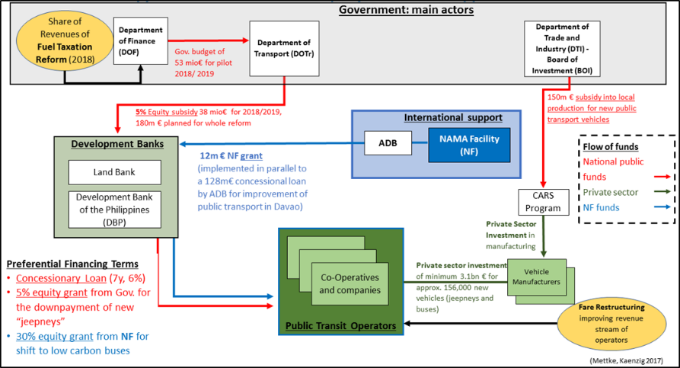

Figure 1: Financing mechanism of direct mitigation measures ##for additional figure just copy-paste and then right click on the number (i.e. the field function) and update the field (the correct number appears autmatically)

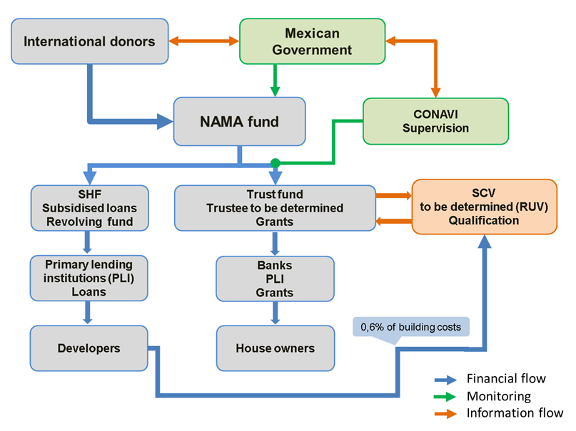

Source: xxx

* 1. Scale of investment and support needs for different ambition levels

***Maximum 2 pages***

***Guiding questions:*** *Amount of public and**private resources needed to implement (different ambition levels) of the mitigation action? What is secured, what is the financing gap?*

Use the same scenarios as in Sections 4 and 6 and describe the amount of investment and type of resources (loan, grant, etc.) needed from different sources (local public, private and international public) to achieve the impacts in the respective scenarios. Use a table, see example below.

Figure 2: Scale of investment and financial support needed

|  |  |  |  |  |
| --- | --- | --- | --- | --- |
|  |  | Low Scenario | Medium Scenario | High Scenario |
|  |  | ##details, e.g.  1000 new buses |  |  |
| Impact | MtCO2e over 10 years |  |  |  |
|  | Other benefits |  |  |  |
| Needed investment (ensured) | Local public | 780 (520) |  |  |
| (In million EUR) | Private |  |  |  |
|  | International public |  |  |  |

Describe amount needed and amount secured highlighting opportunities for the 3 categories.

Secured funding and funding gaps

Describe the host countries’ contribution and other institutions’ contributions (such as ODA, MDB, NGOs, private sector) that are already secured to finance NAMA implementation,

Opportunities for the private sector

Include wherever feasible options for the private sector.

Opportunities for the international donor community

Describe where international development or climate finance could play a role.

1. Expected benefits and MRV approach

**Helpful material explaining nicely the approach we follow on MRV:**

* UNFCCC MRV compendium: <https://www.changing-transport.org/publication/the-passenger-and-freight-transport-volume-of-the-compendium-on-ghg-baselines-and-monitoring/>
* GIZ TraCS/TRANSfer Reference document on transparency in transport: <https://www.changing-transport.org/wp-content/uploads/2018_Reference_Document_Transparency-in-Transport_2nd-ed.pdf>
* GIZ MRV blueprints (specific MRV guidance for selected individual measures):
  + NUMP: <https://www.changing-transport.org/wp-content/uploads/2015_Eichhorst_Bongardt_MRVBlueprintUrban-PassengerTransport-NAMAChina.pdf>
  + Rail shift: <https://www.changing-transport.org/wp-content/uploads/2015_Gruetter_MRVBlueprintRailwayNAMAIndia.pdf>
  + Low resistance tyres: <https://www.changing-transport.org/wp-content/uploads/2015_Duennebeil_Keller_MRVBlueprintMonitoringLowRollingResistanceEU.pdf>
  + Fuel Economy Standards: <https://www.changing-transport.org/wp-content/uploads/2017_FES_GHG_Evaluation_Guide.pdf>
  1. Cause-impact chain

***Maximum 2 pages***

***Guiding questions:*** *What are the direct and indirect GHG and non-GHG effects of the different actions foreseen under the mitigation action? Which are most relevant? Which parameters are suited to measure the effects?*

Describe causal chain mapping results and provide a figure to illustrate the cause-effect chain.

Describe direct and indirect GHG and non-GHG effects, their relevance and if they are included in the MRV approach.

**Examples**

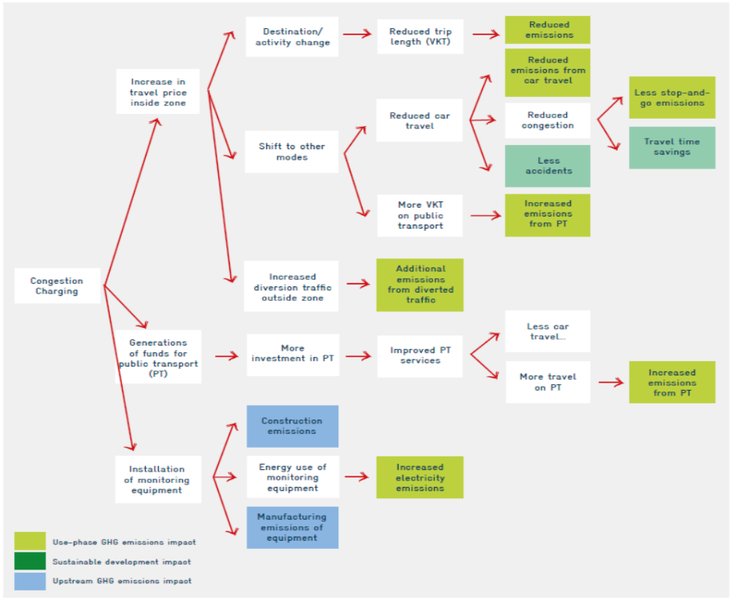

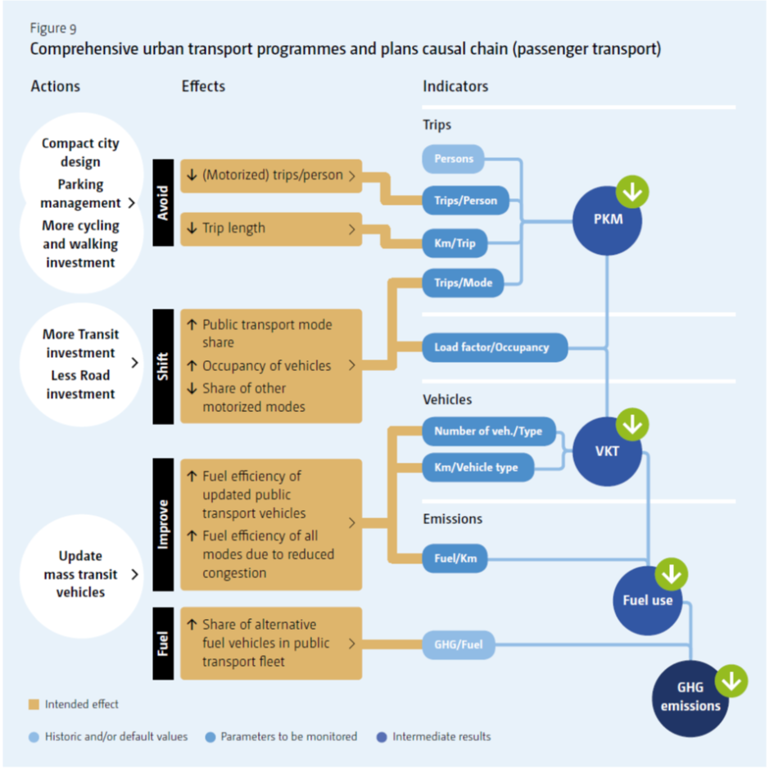

* 1. Assessment boundaries

***Maximum 1.5 pages***

***Guiding questions:*** *Which direct and indirect GHG and non-GHG effects are considered and why?*

Describe temporary, sectoral and geographical boundaries as well as the types of GHG emissions (CO2, CH4, etc.) and sustainable development benefits that are considered.

Clarify whether you use a well-to-wheel or tank-to-wheel approach.

**Example** of a table that helps to summarize the main elements.

Table 6: Assessment boundares

|  |  |
| --- | --- |
| Boundary elements | Description |
| **Temporal boundary** | 2016-2026 |
| **Sectoral boundary** | The assessment covers road based public transport activities, in particular by jeepneys, buses, and mini-buses. |
| **Territorial boundary** | Due to the nature of the mitigation activity, the territorial boundary distinguishes between two layers of analysis:  At the national level the territorial boundary includes all pilot cities and their respective territorial assessment boundary.  At the city level, for each city implementing consolidation and modernisation of their public transport services a suitable territorial boundary is determined, which can differ between component A and B.  For Metro Manila the exact routes to be covered in the ex-post analysis will depend on the choice of pilot applications for component A and B. |
| **GHG included** | The focus is on direct, activity-based GHG emissions. The monitoring covers tank-to-wheel CO2, CH4 and N2O and CO emissions, as well as emissions related to electricity generation, which are also included as direct emission source in the case of electric jeepneys.  Indirect upstream emissions for fuel production or vehicle manufacturing are not covered. |
| **Sustainability effects included** | Estimates of pollutant emissions cover particulate matter (PM), nitrogen oxide (NOx), sulfur oxide (SOx), carbon monoxide (CO), and non-methane hydrogen compounds (NMHC) from road-based public transport activities within the territorial boundaries.  In addition, road accidents and formal employment created vs. jobs lost / income developments of drivers and operators are also monitored.  Energy security is assessed based on the net fuel savings of the mitigation activities, which are calculated anyhow for GHG emissions assessment. |

Source: Own overview

* 1. Ex ante impact assessment
     1. Baseline and mitigation scenarios

***Maximum 1 page***

***Guiding questions:*** *What is the business as usual scenario (BAU, baseline) and which mitigation scenarios did we analyze?*

Describe BAU and mitigation scenarios in an easy to understand way. Give the scenarios easy to understand and remember names.

Explain the core assumptions behind the different scenarios, describe how they were fixed and validated (e.g. literature review, expert judgements in expert workshops), and highlight main uncertainties.

IMPORTANT: Make sure to present numbers of projections over the 10 years horizon that is assessed for all mitigation action prepared by TRANSfer in order to all for comparison and aggregated impact reporting.

**Example of an introductory text (not the complete section)**

This section describes the Baseline or Business as Usual scenario and the different mitigation scenarios. The development of different parameters (CO2 emissions, xxx, xxx) under the Business as Usual (BAU) scenario shows how these parameters are expected to develop in absence of any intervention, i.e. without implementing the measures conforming this mitigation action and described in Section 4. Baselines are required to determine the impact of the mitigation impact compared to a reference case (the baseline). The calculation of the GHG mitigation potential and the estimation of the sustainable development benefits is based on the following scenarios and main assumptions. Since this assessment is realised before implementing the mitigation action, it is called *ex ante* impact assessment.

Table 7: BAU and mitigation scenarios

|  |  |  |
| --- | --- | --- |
| Scenario | Main assumptions and sources | Uncertainties |
| Baseline Scenario (BAU) | Assumption (source)  … | Uncertainty… |
| Scenario 1 “##simple name” | Assumption (source)  … | Uncertainty… |
| Scenario 2 “##simple name” | Assumption (source)  … | Uncertainty… |
| Scenario 3 “##simple name” | Assumption (source)  … | Uncertainty… |

Source: GIZ

* + 1. Methodology for calculation

***Maximum 1.5 pages***

***Guiding questions:*** *How is the ex ante assessment calculated?*

Explain the calculation methodology with formulas and explain all abbreviations used.

The specific approach depends very much on the bundle of measures and the data availability in the country. Get inspired by the examples collected as “blueprints” and in the reference document mentioned at the beginning of this chapter.

Make sure to present the methodology used for GHG and non-GHG impact assessment!

**Example**

The baseline GHG emissions in this report are defined as the business-as-usual scenario without the NAMA activities, i.e. no consolidation and rationalisation of jeepneys and buses and no operation of higher occupancy clean city buses in major routes. Old jeepney units are assumed to continue to operate in competition with buses in major traffic corridors. Meanwhile, the public transport franchise moratorium is assumed to be extended such that there is no growth in jeepney numbers, although some growth in passenger trips is assumed due to land use changes and economic growth.

For workstream A, the Average Annual Daily Traffic (AADT) represents transport activity in identified routes or corridors. It is a measure of traffic flow typically derived through hourly traffic counting. The AADT is commonly used in emission inventories from road-based transport, and to measure emissions for workstream A, the AADT of all vehicle types are considered to represent traffic activity in the chosen corridors. The AADT is multiplied by the corridor distance as an approximate VKT:

$${VKT}_{RV,y} ={AADT}_{y}*road length$$

$${PKM}_{RV,y} ={VKT}_{y}*average occupancy per vehicle type$$

Where:

VKTRV,y= vehicle kilometers at measurement year y

PKMRV,y= passenger kilometres at measurement year y

For workstream B, calculations are based on the vehicle registration of jeepneys per route, which is available from the DOTr. The fleet population is then multiplied by an assumed annual VKT per vehicle.:

$${Total VKT}_{RV, y} ={Number of registered jeepneys}_{y}*VKT$$

$${Total PKM}_{RV, y} ={VKT}_{RV, y}*average occupancy per unit$$

Where:

VKT and PKM are the vehicle kilometres and passenger kilometres of jeepneys at measurement year y

In both cases, baseline emissions are those of old jeepneys (and old buses in case of workstream A), which would have been used in the absence of the new city buses or the new replacement jeepneys/mini-buses, respectively. Emissions are calculated based on the alternative PKM values (in order to account for different seating capacities).

* + 1. Data

***Maximum 2 pages***

***Guiding questions:*** *Which data was used? How is data availability and quality?*

Briefly describe data collection and assess data and quality.

Present general data (e.g. rates, fuel price, vehicle prices, etc.) and scenario specific data in a table (see example below).

Make sure to include data related to GHG and non-GHG impact assessment.

Explain assumptions for values that change over time.

**Example**

Table 8: Used data

|  |  |  |  |
| --- | --- | --- | --- |
| Parameter | Notation | Value and unit | Source |
|  |  |  |  |
|  |  |  |  |

Source: GIZ

* + 1. Expected benefits
       1. GHG mitigation impact

**Maximum 1 page**

***Guiding questions:*** *What GHG benefits do we expect?*

Describe only the core results: estimated GHG mitigation potential of entire mitigation action.

Important note: You can present results for several time horizons but but make sure to include a presentation of accumulated GHG savings over 10 years to enable aggregated reporting for the sum of all mitigation actions prepared by TRANSfer.

**Example** shows how to present the core information expected in this section:

The mitigation action is expected to achieve accumulated GHG emission reductions in the range of XX to XX MtCO2e over 10 years between 20xx and 20xx (##Attention: Make sure to present accumulated over 10 years!). This translates into an average annual GHG emission reduction of X to X MtCO2e and X MtCO2 in 20xx (##year 10 or e.g. NDC target year). The implementation of the mitigation action will reduce the total yearly transport GHG emissions in ##name of country## by X% and contribute with X MtCO2 or XX% to achieve the NDC target for the transport sector of minus X MtCO2 in 20XX or accumulated until 20XX. The following table summarises the core numbers for the ##two / three## different scenarios compared to the baseline scenario.

Table 9: Ex ante GHG Impact Assessment 2016 – 2026

|  |  |  |  |
| --- | --- | --- | --- |
|  |  | Low Scenario: 70% shift  (in MtCO2e accumulated over 10 years) | High Scenario: 100% shift  (in MtCO2e accumulated over 10 years) |
| Workstream A: Fleet Consolidation | **Metro Manila** | 1.8 | 2.5 |
| **Philippines** | to be estimated | to be estimated |
| Workstream B: Fleet Modernisation | **Metro Manila** | 1.3 | 1.86 |
| **Philippines** | 4.68 | 6.69 |

Source: Own calculations based on Clean Air Asia (2015)

* + - 1. Sustainable development benefits

**Maximum 2 pages**

***Guiding questions:*** *What non-GHG benefits do we expect?*

To the extent possible, calculate the benefits in quantitative physical terms and monetize them.

Describe sustainable development benefits in a text, e.g. health, traffic safety, physical activity, improved working conditions, jobs or income creation, time savings / less time lost in traffic, quality of life, noise reduction, further environmental benefits (efficient use of scarce resources, reduction of local air pollutants, etc.), increased efficiency of the system as a whole.

In addition, realise a qualitative assessment using a table (see table below).

**Example**

Below example is from Jeepney+ NAMA (Public Transport Reform). A further example for active transport and transport demand management can be found on pages 48ff under this link: <https://www.changing-transport.org/wp-content/uploads/02-NAMA-TAnDem-Documento-conceptual-inglés.pdf>

The mitigation action is expected to generate **various sustainability benefits** besides GHG emission reductions. The improvement of public transport services is expected to result in **reduced congestion and travel time and better quality of service** to public transport users, **improved air quality and road safety**, **better working conditions** for providers of public transport services and contribute to **fuel security** by reducing fuel demand (see Chapter X for more details).

By reducing the total amount of jeepneys by approximately 22% due to the consolidation of the market and the rationalisation of the service network, the benefits in terms of time savings and local air pollutants will be significant. The improvement of the overall economic situation for the industry as a consequence of a row of interventions, such as joint fleet management, usage of new, more efficient, vehicles, and introduction of jeepney stops or the discontinuation of the “boundary system” will lead to a most sustainable socio-economic environment of the industry stakeholders. Furthermore, the situation for the public transport users or customers will improve significantly due to reduced travel times, safer vehicles and less local pollution, which is beneficial for drivers. Due to the importance of the public transport market in the Philippine society and as a result of the market transformation, all envisaged interventions of the Jeepney+ NAMA will lead to sustainable development benefits if successfully implemented.

The modernization of the jeepney fleet in Metro Manila, combined with the rationalization of public transport services in the major corridors would result in total on-road **diesel savings** between 528 to 754 million litres (up to 2026) or 310 million to 443 million USD.[5] If the impacts of the scaled up jeepney modernization program (nationwide) are included, the total amount of diesel to be saved can be between 1.9 to 2.7 trillion litres (or 1.9 to 2.7 billion per year) or 1.1 to 1.5 trillion USD.

In terms of **local air pollutant reduction**, the ex-ante estimated potential for Metro Manila was calculated. **Fehler! Verweisquelle konnte nicht gefunden werden.** below provides the **estimated average pollutant emissions avoided per year** due to the NAMA. Pollutants affect health, destroy infrastructure and damage agriculture, and with the implementation of the Jeepney+ NAMA, significant amounts of air pollution can be avoided.

Table 10: Total pollutant emissions avoided in Metro Manila from 2016 to 2026 (tons/year)

|  |  |  |  |  |  |  |
| --- | --- | --- | --- | --- | --- | --- |
|  |  | PM | CO | Nox | SOx | NMHC |
| Route Rationalization | **Low** | 107.69 | 656.04 | 362.98 | 0.58 | 193.67 |
| **High** | 153.85 | 937.20 | 518.54 | 8.43 | 279.56 |
| Jeepney Technology Modernization | **Low** | 276.71 | 1,858.79 | 558.80 | 0.16 | 570.60 |
| **High** | 395.30 | 2,655.42 | 798.28 | 0.23 | 815.15 |

Source: GIZ

The **monetized health value** of the reduced air pollutants in the table above are estimated to be **between 83 to 119 million USD per year**. If the scaled up program for the jeepney technology modernization is accounted for, the **monetized value of air pollution reduction** is estimated to be in the range of **220 to 316 million USD per year**.[6]

NAMA implementation yields a number of significant sustainable development benefits. While a quantitative assessment will only been carried out during the pilot phase, **Fehler! Verweisquelle konnte nicht gefunden werden.** shows a qualitative assessment of the major expected benefits associated with NAMA implementation.

Table 11: Qualitative assessment of co-benefits (sustainable development benefits)

|  |  |  |
| --- | --- | --- |
| Main co-benefits | Relative importance | Justification |
| Socio-economic | | |
| Decreased travel times and associated economic benefits | *High* | *Traffic congestion can be substantially decreased (rationalised service and network plan; consolidation of public transport fleet; introduction of joint fleet management; )* |
| Reduced stress levels and diseases (and consequent reduced societal health costs) associated with traffic noise/air pollution | *High* | *Long-term impact due to the reduced traffic noise/air pollution* |
| Reduced casualties and injuries by accidents | *High* | *Reduced traffic and modernised public transport vehicle fleet* |
| Increased income for public transport industry | *High* | *Rationalised and modernised public transport system will lead to higher revenues and income situations* |
| Increased competitiveness of cities as attractive places for business/families | *Low* | *A better mobility attracts families and businesses* |
| Social inclusion of people of vulnerable groups | *High* | *Implementation of vehicle standards will improve (physical) accessiblity to public transport* |
| Environmental | | |
| Reduced traffic related air pollution (NOx, SOx and particulate matter) | *High* | *Stringent vehicle standards, reduced fuel consumption and emissions due to optimized number of road public transport vehicles, as well as potential shifting of trips from private modes.* |
| Rational use of scarce resources, e.g. fossil fuels | *High* | *Stringent vehicle standards, reduced fuel consumption and emissions* |
| … |  |  |

Source: Own elaboration

* 1. Monitoring and reporting plan

***Maximum 4 pages***

***Guiding questions:*** *Who will monitor and report what and how often during implementation of the mitigation action(s)?*

Describe the monitoring and reporting plan covering the three main elements listed below considering the orientation from NAMA Handbook and the MRV Reference Document (see links above) and previous NAMA concept documents.

Explain briefly the **(1)** **needs of different targets groups** and what will be monitored and reported to whom? Typically, domestic audience, UNFCCC and international donors have different needs (see small table below).

Highlight how your plan contributes to UNFCCC related reporting (NDC, National Communications, Biannual Update Reports).

Describe and list the **(2a)** **indicators** that will be monitored during implementation and what will be done to improve **(2b)** **data availability and quality** in critical areas (highlighted in Section 6.3). Consider indicators necessary to report on

* GHG impacts
* non-GHG impact
* implementation progress

Describe the **(3)** **institutional set-up**, i.e. how monitoring and reporting will be organized and who will be responsible for what (process coordination, data collection for the different indicators, preparation and submission of reports, etc.). Present a flow chart.

**Examples and guidelines**

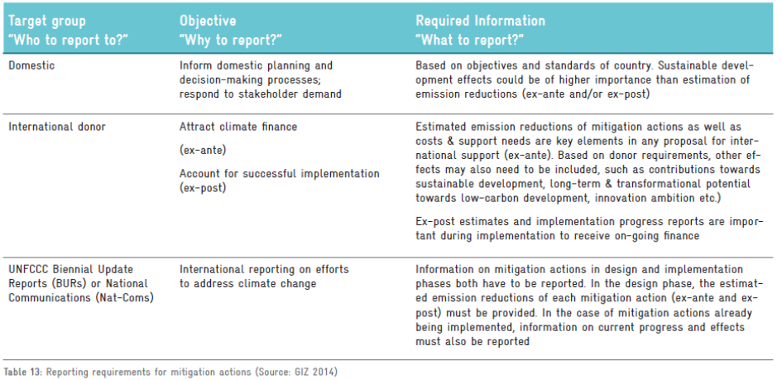

Table 12: Parameters for GHG impact monitoring

| Data | Notation | Indicator | Unit | Source / Data Collection Method | Collection Frequency | Collecting Agencies |
| --- | --- | --- | --- | --- | --- | --- |
| Vehicle population | N | The number of registered jeepney units | No. of vehicles | Through vehicle registration | Annual | LTO |
| Ridership | R | Number of passengers in a given measurement year | Passengers/  year | Self-monitoring report /  Sample surveys for operators | Annual | Operators/ LTO  OTC |
| Vehicle trips of jeepneys | tRV | The trips made per vehicle in a specified route/corridor | No. of trips/  Vehicle/yr. | Self-monitoring report | Daily | Operators/ MMDA/ DPWH |
| Trip distance | dRV | The distance travelled per vehicle per trip | km/trip | Odometer measurements/  GPS installations per unit /  Sample surveys | Daily | Operators/ MMDA/ DOTr |
| Operating days | DRV | Number of days in operation per vehicle | Days/ vehicle | Self-monitoring report of operator | Annual | Operators/ DOTr |
| Speed | S | The average speed per vehicle | Km/h | Odometer measurements | Daily | MMDA/ DOTr |
| Fuel split | %Fuel | The frequency distribution of the vehicle population per fuel type i.e. Diesel, Gasoline, Electric, etc. | % Fuel type | Vehicle registration forms | Annual | LTO |
| Technology Split | %Tech | The frequency distribution of the vehicle population per technology type i.e. Euro I, Euro II, Euro III, etc. | % Technology type | Vehicle registration forms | Annual | LTO |
| Fuel consumption | FC | The total fuel consumed per vehicle | Litres | Self-monitoring reports from operators | Ad hoc | Operators/ DOTr |
| Electricity consumption (e-jeepneys) | EC | The total electricity consumed over the distance travelled per electric vehicle | kWh/day | Self-monitoring reports from operators based on daily charging | Daily | Operators/ DOTr |
| Emission factors | EF | The amount of CO2 per litre | gCO2/litre; gCO2/MJ | Lab measurement (Vehicle inspection / PETC) | Ad hoc | UP NCTS/ VRTL |

Table 13: Monitoring parameters for sustainable development impacts

|  |  |  |  |  |  |
| --- | --- | --- | --- | --- | --- |
| Sustainable development benefit | Indicator(s) | Unit | Source / Data Collection Method | Collection Frequency | Collecting Agencies |
| Air quality | Estimated amount (tons) PM, NOx, SOx, CO, NMHC;  Mg/m3 levels for selected pollutants (as monitored by the available air quality stations in Metro Manila PM, SO2, NO2) |  | Calculated on the basis of average emission factors based on fuel savings calculated for the emission reductions  AQ monitoring stations | Annually  Aggregated annually |  |
| Road safety | Road accidents (ideally on the affected roads) |  | Based on city statistics by MMDA | Every five years |  |
| Formal employment | Number of new formal jobs created through consolidation |  | Public transport cooperatives | Annually from the start of pilot implementation |  |
| Number of jobs lost |  | Own survey | Annually |  |
| Energy security | Net fuel savings |  | Taken from calculations for emissions reductions | Annually |  |

Source: Own table

Bibliography

Agree on a suitable referencing style depending on what is used in the country (e.g. APA, MLA, Harvard, etc) and apply throughout the whole document. In case many different sources are used, a distinction can make sense (see below).

Relevant national and local policies, programs and regulations

* Dawson, R. (2007): Re-engineering cities: a framework for adaptation to global change. Philosophical Transactions of the Royal Society A, 365: 3085-3098.
* Dawson, R. (2007): Re-engineering cities: a framework for adaptation to global change. Philosophical Transactions of the Royal Society A, 365: 3085-3098.

Relevant technical studies

* Dawson, R. (2007): Re-engineering cities: a framework for adaptation to global change. Philosophical Transactions of the Royal Society A, 365: 3085-3098.
* Dawson, R. (2007): Re-engineering cities: a framework for adaptation to global change. Philosophical Transactions of the Royal Society A, 365: 3085-3098.

Further documents

* Dawson, R. (2007): Re-engineering cities: a framework for adaptation to global change. Philosophical Transactions of the Royal Society A, 365: 3085-3098.
* Dawson, R. (2007): Re-engineering cities: a framework for adaptation to global change. Philosophical Transactions of the Royal Society A, 365: 3085-3098.

Annex 1: Logframe

Provide annexes with details, in particular from separate technical studies, e.g.

Annex 2: Cause-effect chain

Annex 3: Core elements from financial studies

##e.g. sensitivity analysis

|  |
| --- |
| As a federally owned enterprise, GIZ supports the German Government in achieving its objectives in the field of international cooperation for sustainable development.  **Published by:**  Deutsche Gesellschaft für  Internationale Zusammenarbeit (GIZ) GmbH  Registered offices  Bonn and Eschborn  Friedrich-Ebert-Allee 36+40  53113 Bonn, Germany  T +49 61 96 79-0  F +49 61 96 79-11 15  E info@giz.de  I www.giz.de  **Author/Responsible/Editor, etc.:**  Name, town  **Design/layout, etc.:**  Name, town  **Photo credits/sources:**  Photographer, photo agency or GIZ staff member (GIZ/name)  **URL links: ##if applicable, delete if no links are included in the publication**  This publication contains links to external websites. Responsibility for the content of the listed external sites always lies with their respective publishers. When the links to these sites were first posted, GIZ checked the third-party content to establish whether it could give rise to civil or criminal liability. However, the constant review of the links to external sites cannot reasonably be expected without concrete indication of a violation of rights. If GIZ itself becomes aware or is notified by a third party that an external site it has provided a link to gives rise to civil or criminal liability, it will remove the link to this site immediately. GIZ expressly dissociates itself from such content.  **Maps: ##if applicable, delete if no maps are included in the publication**  The maps printed here are intended only for information purposes and in no way constitute recognition under international law of boundaries and territories. GIZ accepts no responsibility for these maps being entirely up to date, correct or complete. All liability for any damage, direct or indirect, resulting from their use is excluded.  **Printing and distribution:**  Name, town  Printed on 100% recycled paper, certified to FSC standards.  Location and year of publication |
|  |



## Placeholder for Picture on the Back

Deutsche Gesellschaft für  
Internationale Zusammenarbeit (GIZ) GmbH

Registered Offices   
Bonn and Eschborn

Friedrich-Ebert-Allee 36+40  
53113 Bonn, Germany

T +49 228 44 60-0   
F +49 228 44 60-17 66

E [info@giz.de](mailto:info@giz.de)  
I www.giz.de

##Placeholder for Back-Picture

1. CAF supports the programme by realization of studies; AFD co-finances projects under this initiative via the French Global Environment Facility.
2. These estimates are thought to provide an order of magnitude of costs resulting from NAMA implementation. Exact cost data will depend on detailed project design and technology selection in each city.
3. Operation costs for rickshaw service and parking management schemes are not considered as operation is assumed cost efficient.
4. Operation costs for rickshaw service and parking management schemes are not considered as operation is assumed cost efficient.
5. Based on pump price of 28 pesos per liter and 0.21 Php/USD.
6. The monetized values are estimated using monetized health impact factors based from Biona et al (2017) which represent aggregated costs associated with a ton of a certain type of pollutant (limited to PM, SOx and NOx).